**MEANING AND USES OF ANSIBLE**

**Meaning of Ansible:**

Ansible is an open source IT automation engine that automates provisioning, configuration management, application deployment, orchestration, and many other IT processes.

History of Automation (From my Perspective) :

* Bash Scripting / Batch Scripting
* Python / PERL / Ruby
* Powershell (Owned by Microsoft)
* Puppet (The real function of puppet is for managing Configuration of servers through a centralized server, In the adoption of DevOps, it was upgraded to an Automation tool, It is built on Ruby)
* Salt Stack (Became famous with the combination with Puppet. It is built on python)
* Chef (Came with more power, becos it has the advantage of writing Ruby codes, graphical user interface)
* Ansible (The most simplest Automation tool, simple code to manage your huge infrastructure )
* Terraform (Cloud specific Automation)

**USES OF ANSIBLE**

* It is used to Automate:
* Servers and storages.
* Network devices, firewalls, software-defined networks (SDNs), and load balancers.
* Application components.
* Containers and container platforms.
* Database applications.
* Public cloud and private cloud.

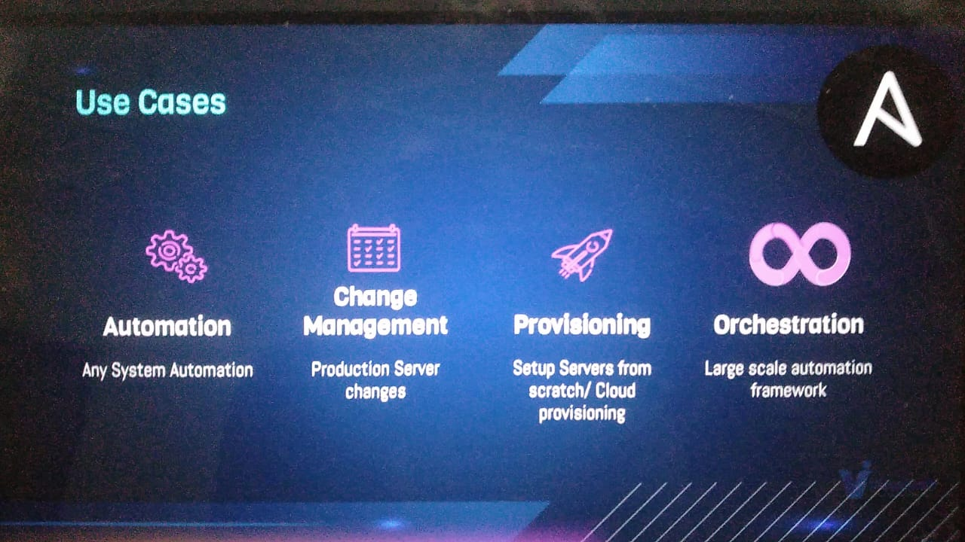

Ansible is Simple:

* No need for Agents (Target machines/services are accessed by SSH, WINRM & API)
* No Databases (YAML, INI & Texts)
* No Complex Setup (It’s just a Python Library)
* No Residual Software (Push Python package, Execute, Return Output)
* Uses YAML format which is easy to read and write
* Uses API (URL/Restful Calls(e.g. Cloud), Shell Commands, Scripts)

**HOW ANSIBLE CONNECTS:**

Linux – Uses SSH

Windows – Uses WINRM (Enable remote connection in windows)

Cloud – API calls

Switches/Routers/Databases – Uses Python Libraries

